Installation Of TRIMIT 26.1 On-Premises
This Document contains information regarding the installation of TRIMIT 26.1 for Microsoft Dynamics 365 Business Central on-premises 2026 release wave 1, with at least Build 28.0.XXXXX.XXXXX.
This document is for Developers and experienced Consultants, hence the instructions do not include detailed menu paths, as it is expected that handling Business Central is common knowledge.
The package for TRIMIT 26.1.XXXXX can be downloaded here or via AppSource.
The package for TRIMIT Data and Test 26.1.XXXXX can be downloaded here.
The TRIMIT AddOn packages for Tasklet Factory, Continia Document Capture, ForNav, ClickLearn, Delogue PLM, Front Systems and TRIMIT Sustainability can be downloaded here.

The installation of TRIMIT requires the following actions:
- Installation of at least Microsoft Dynamics 365 Business Central on-premises 2026 release wave 1, Build 28.0.XXXXX.XXXXX (simply take the last released Update of 2026 release wave 1)
- See System requirements for Business Central 2026 release wave 1 - Business Central | Microsoft Learn for more details regarding the requirements for an on-premises Installation.
- Customer Business Central License
- Installation of TRIMIT on the Microsoft Dynamics 365 Business Central on-premises 2026 release wave 1
- Installation of the TRIMIT AddOns (Optional)
- Online Help
- Installation of the TRIMIT License file
- Creation of TRIMIT Demo Data

This document will guide you through these processes. All files (besides the Business Central installation itself) can be found on MyTRIMIT.

NOTE
This document describes a new installation. For the upgrade of an existing TRIMIT installation, please look in the Upgrade Instructions document.

Contact
If you discover an issue while performing this Guide, please register an Service Request or send an E-Mail to partnersupport@trimit.com.

Disclaimer
Read these guidelines before you perform an Installation on your live database.
TRIMIT Solutions A/S, Partners of TRIMIT Solutions A/S or others cannot be held responsible for any damage caused by the installation of TRIMIT.

Version: 26.1
Date: 29-04-2026

Contents
Client/Server for 365 Business Central 5
Microsoft Dynamics 365 Business Central License File 5
TRIMIT 26.1 5
Installation Process 5
Localizations 6
Preconditions 6
Extra TRIMIT PTE Apps 7
TRIMIT for Tasklet Factory 7
TRIMIT for Continia Document Capture 7
TRIMIT for ForNAV 7
TRIMIT for ClickLearn 7
TRIMIT for Delogue PLM 7
TRIMIT for Front Systems 7
TRIMIT Sustainability App 8
TRIMIT Online Help 9
TRIMIT License file 11
Preconditions 11
Procedure 11
API Service URL 13
Demo Company 13
Installation Demo Data Process for Demo Purposes 13
Installation of TRIMIT on Active TRIMIT Database 14
Extra Localized Data (Optional) 15
BE Localization 15
No. Series 15
General Journal Templates 15
Sales & Receivables Setup 15
Purchase & Payables Setup 15
Table 36 Sales Header 15
Table 38 Purchase Header 15
Table 313 Inventory Setup 16
NA Localization 16
CH Localization 16
FI Localization 16

Client/Server for 365 Business Central
TRIMIT 26.1 is advised to be installed on at least Microsoft Dynamics 365 Business Central on-premises 2026 release wave 1, Build 28.0.XXXXX.XXXXX
TRIMIT 26.1 can also be installed on any Update of Microsoft Dynamics 365 Business Central on-premises 2026 release wave 1 – BC28.1, BC28.2, BC28.3. etc.

Microsoft Dynamics 365 Business Central License File
TRIMIT 26.1 requires a Microsoft Dynamics 365 Business Central license file.
Request this from Microsoft Order Central or via MyTRIMIT, where you need to create the Customer first, after which you can determine which License you need for this Customer:
https://my.trimit.com/sales/licenses/create-customer.html in case of Embedded Licenses.

TRIMIT 26.1
Content of the package:
- TRIMIT Application (No. 6 in the picture below)
- Release documentation

Translation Worksheets for partners to supply TRIMIT with corrected/additional translations will be published on a separate page on MyTRIMIT:
https://my.trimit.com/product/product-download/translations.html

Installation Process
- Install the localized Microsoft Dynamics 365 Business Central on-premises 2026 release wave 1, with at least Build 28.0. XXXXX.XXXXX, which includes at least the four Extensions:
Application, Base Application, Business Foundation and System Application. (Nos. 1, 2, 3 and 5 in the picture below)
There might however be other localized extensions.
Follow the instructions provided by Microsoft.
- Publish and Install the TRIMIT Application (No. 6 in the picture below).
While installing the TRIMIT Application, also the Permission Sets of TRIMIT will be written to the database.

- In case it is not already published and installed: Publish and Install the Email – SMTP Connector Application (No. 4 in the picture below). This is necessary if you want to use the TRIMIT E-Mail functionality, especially for the TRIMIT e-commerce.

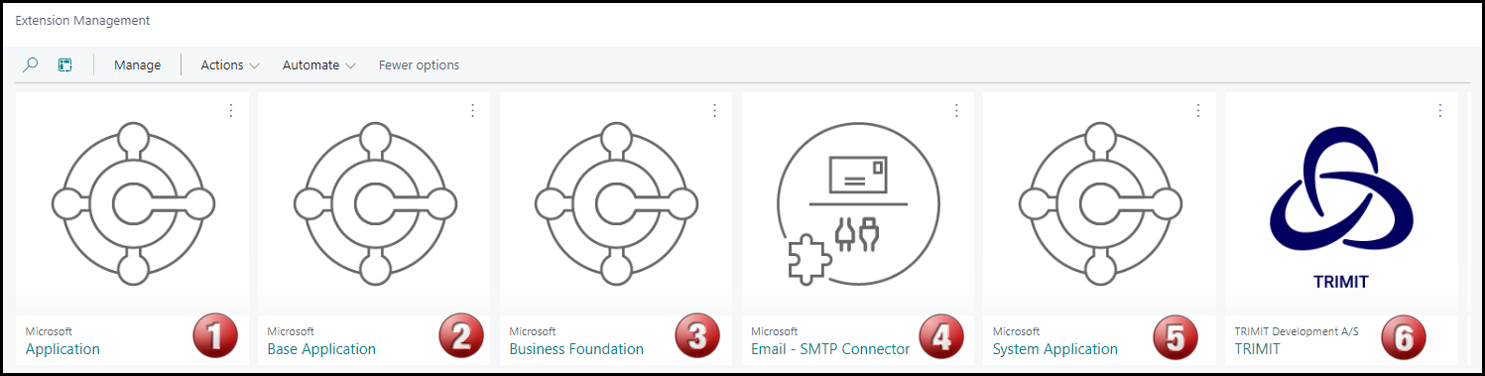

See the following link for how to install the necessary extensions:
https://docs.microsoft.com/en-us/dynamics365/business-central/dev-itpro/developer/devenv-how-publish-and-install-an-extension-v2

Localizations
Be aware that the Localizations are now handled in the Microsoft Base Application (No. 2 in the picture above).

Preconditions
- Microsoft Dynamics 365 Business Central on-premises 2026 release wave 1, with at least Build 28.0.XXXXX.XXXXX is established with the Customers Business Central License file.

For an installation of TRIMIT for Demo purposes, see Installation Process for Demo Purposes

Extra TRIMIT PTE Apps

TRIMIT for Tasklet Factory
Specifically, if you also install and use the functionality of Tasklet Factory, you need to publish and install the special TRIMIT AddOn Mobile WMS App after you install the Tasklet Factory App.
This will enable the use of the TRIMIT Pick Document as the document for which you want to register the picked quantities on a handheld device for scanning by using Tasklet Factory.

TRIMIT for Continia Document Capture
Specifically, if you also install and use the functionality of Continia Document Capture, you need to publish and install the special TRIMIT AddOn Document Capture App after you installed the Continia App.
Especially when you use the Document Capture App for incoming Purchase Orders, Receipts and/or Invoices, you might get an error regarding the creation of the Lines.
In TRIMIT we use the special Matrix Lines and the underlying Item Lines, which requires a small addition while creating the Purchase Lines.

TRIMIT for ForNAV
Specifically, if you also install and use the functionality of ForNAV, you need to publish and install the special TRIMIT AddOn ForNAV App after you install the ForNAV Apps.
For the TRIMIT Sales Document reports and TRIMIT PDM Reports for Masters, we created special reports that embrace the ForNAV approach of reports, also regarding the usage of Matrices and Pictures in these reports and according to our Report Layout Settings.

TRIMIT for ClickLearn
Specifically, if you also install and use the functionality of ClickLearn, you need to publish and install the special TRIMIT AddOn ClickLearn App after you install the ClickLearnHelp App.
This will show a ClickLearn icon on the TRIMIT Profiles (Role Centers) for capturing processes for ClickLearn.

TRIMIT for Delogue PLM
Specifically, if you also install and use the functionality of Delogue PLM, you need to publish and install the special TRIMIT AddOn for Delogue PLM after you install the Delogue PLM App.
With our TRIMIT AddOn for Delogue PLM, you are able to easily connect Delogue PLM to your TRIMIT solution and therefore being able to get lots of Master/Item related data from Delogue PLM into the appropriate Tables of TRIMIT and Business Central.

TRIMIT for Front Systems
Specifically, if you also install and use the functionality of Front Systems, you need to publish and install the special TRIMIT AddOn for Front Systems Integration after you install the Front Systems App.
With our TRIMIT AddOn for Front Systems Integration, you are able to easily connect Front Systems to your TRIMIT solution and therefore being able to export Item/Inventory data to Front Systems and import orders from Front Systems into the appropriate Tables of TRIMIT and Business Central.

TRIMIT Sustainability App
This App will enhance the functionality of Business Central Sustainability with the possibility to keep track of Sustainability Certificates, their Valid Dates and the Receipts/Shipments of Items for which this Certificate is applicable.

Note
To use the TRIMIT Sustainability App, you also need to install the Sustainability App of Business Central.

For these additional TRIMIT PTE Apps, you can find the appropriate guides in the download page for these Apps.

TRIMIT Online Help
TRIMIT 26.1 is able to show all the published White Papers as Help for the TRIMIT Functionality.
These White Papers – all in English, are written for employees of our Partners and will only describe specific TRIMIT functionality and fields (not standard Business Central functionality and fields).
For this TRIMIT Help, you need to create an Account on https://my.trimit.com/ based on your companies e-mail address.

TRIMIT Help will be available via all our TRIMIT Profiles (Role Centers).
I.e., in TRM_SB - TRIMIT Small Business:
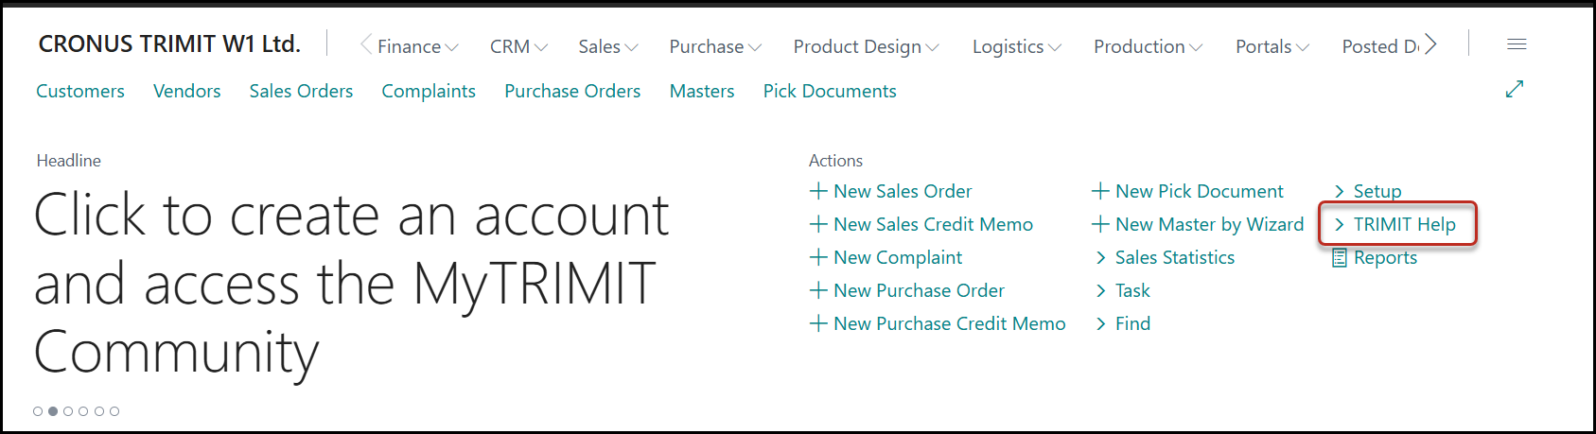
Clicking on TRIMIT Help will forward you to https://my.trimit.com/.
You can use the AI Chat to ask a question, which will answer based on our published White Papers.
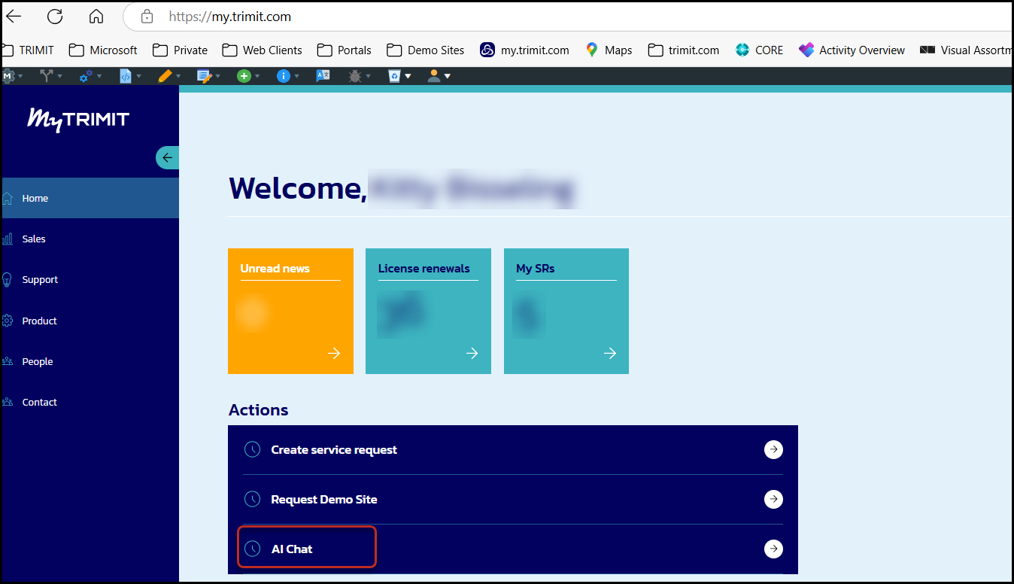

Or you can go to Product, Documentation to view the content of any published White Paper based on the Filters you enter.
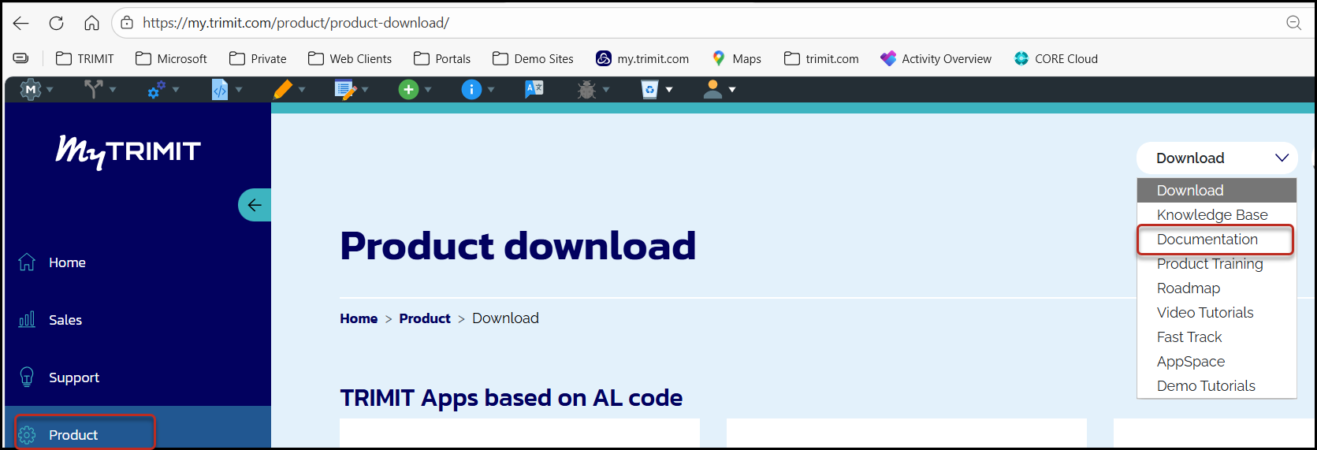
Drill-down option for Product depends on your origin (Customer, Partner, Employee).
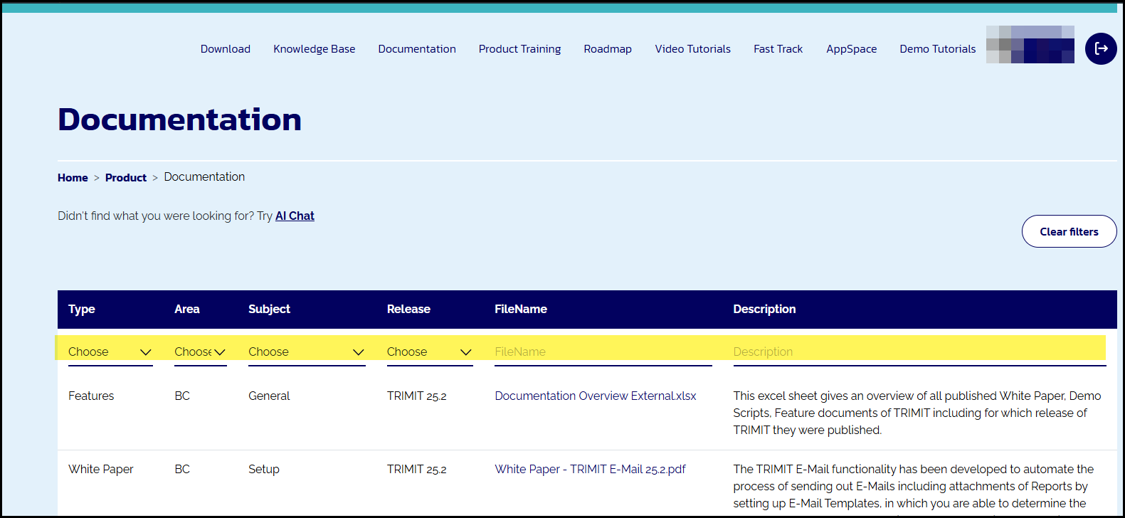

TRIMIT License file
The TRIMIT License file is necessary for Customer Installations and works together with the Dynamics 365 Business Central License file. You can download the TRIMIT License File from MyTRIMIT here based on the order you placed for TRIMIT.

Preconditions
- TRIMIT 26.1 is installed on the Database.
- The TRIMIT License File is placed on the network and can be accessed.

Procedure
Open the Client and click Search to find the Basic Setup, click Import TRIMIT License File
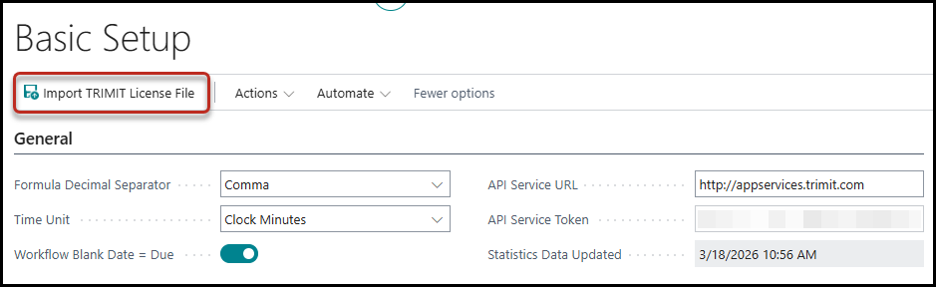
Now you can upload the TRIMIT License File:
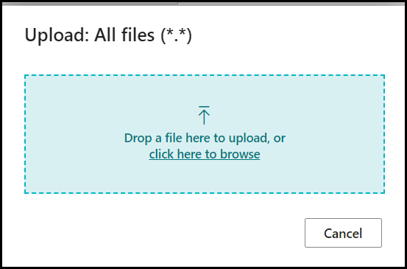
Via Actions, View TRIMIT License you are able to see the content of the TRIMIT License, and check if it is OK, based on the Order you placed on MyTRIMIT.
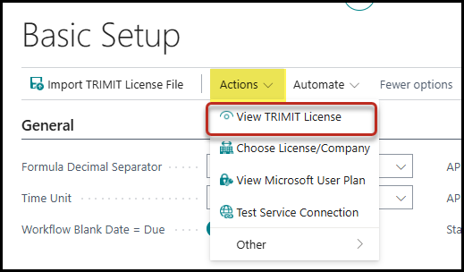
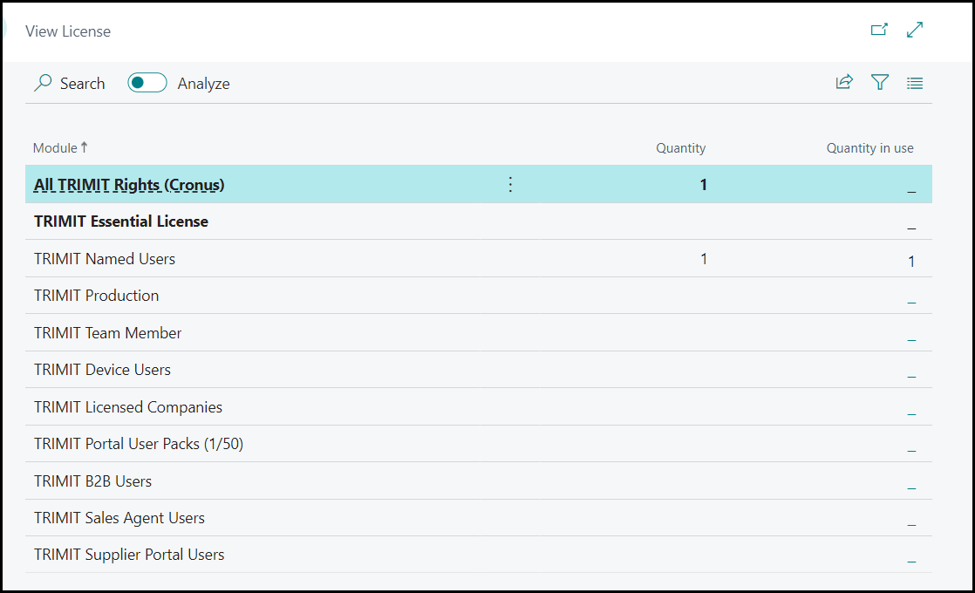
Besides importing the TRIMIT License, you also need to Assign it to the right Companies, especially when working with TRIMIT Intercompany.
This can be done via Actions, Choose License/Company.
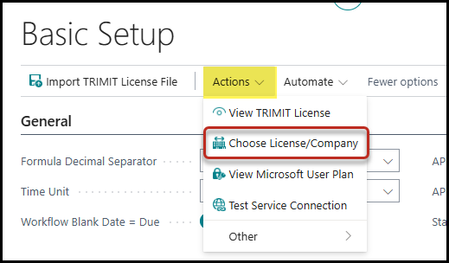
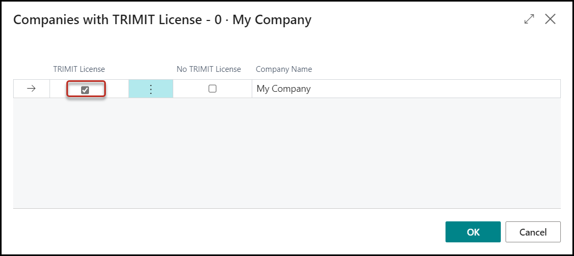

The TRIMIT License file is now installed.

API Service URL
When installing the TRIMIT App, the API Service URL in the Basic Setup will automatically be filled with:
http://appservices.trimit.com
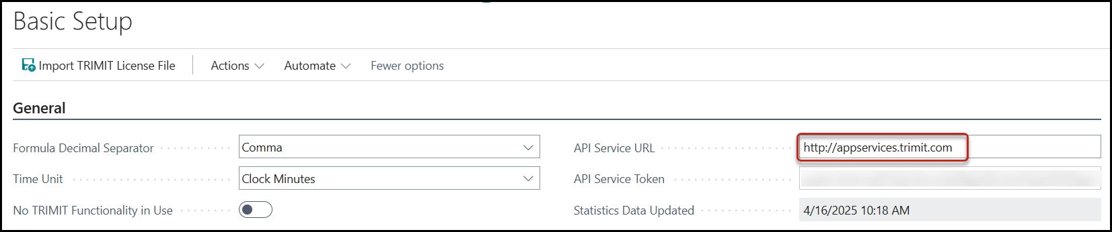
The API Service Token will be filled automatically by the system when needed if the API Service URL is filled will http://appservices.trimit.com. This might be the case for resizing pictures.

Demo Company

Installation Demo Data Process for Demo Purposes
- Install the localized Microsoft Dynamics 365 Business Central on-premises 2026 release wave 1, with at least Build 28.0.XXXXX.XXXXX.
Follow the instructions provided by Microsoft.
- Make sure, you also import/have the default Demo Data of standard Business Central in the database (by installing the demo database of BC).
- See separate Guide for Creation of TRIMIT Data

The Demo Data that can be created with the separate TRIMIT Data and Test App is used to create specific TRIMIT Data for the Demo Scripts and White Papers and can easily be used for demos to prospects or customers.
You can find the Demo Scripts here.
You can find the White Papers here.

Installation of TRIMIT on Active TRIMIT Database
If you have a Customer Database on an BC13R2 or older version of TRIMIT and want to upgrade to
TRIMIT 26.1, you need to consider the following:
- Upgrade tools from TRIMIT BC13R2 to BC21 are available on MyTRIMIT.
- Prepare already the database by re-coding the customization into Extensions and Codeunit Calls into Publishers.
- After that the upgrade to the latest TRIMIT 23.1.XXXXX (based on BC22) is a simple upgrade. This step is however necessary regarding the TRIMIT Permission Sets, that are handled differently as off TRIMIT 22.2.
Therefore, the old TRIMIT Permission Sets need to be ‘converted’ to Permission Sets with Type User-Defined, otherwise they will be deleted when upgrading to TRIMIT 23.1.
- After that the upgrade to the latest TRIMIT 26.1. is a simple upgrade.

Extra Localized Data (Optional)
This might not be necessary, because you would already have the default demo data of a localization, but checking might not hurt. Keep in mind that the descriptions or codes might differ from the pictures below, because they will be in your local language.

BE Localization

No. Series
Add two new No. Series GJNL-PURCR and GJNL-SALCR.
Change the Ending No. of GJNL-PURCH and GJNL-SALES
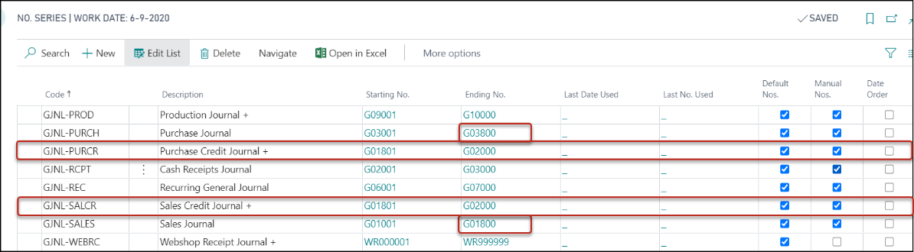

General Journal Templates
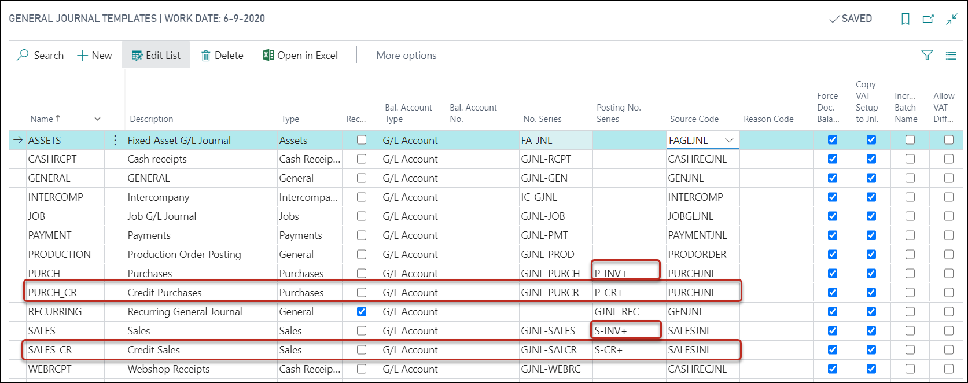

Sales & Receivables Setup
Fill Journal Templ. Sales Invoice with SALES
Fill Journal Templ. Sales Cr. Invoice with SALES_CR

Purchase & Payables Setup
Fill Journal Templ. Purchase Invoice with PURCH
Fill Journal Templ. Purchase Cr. Invoice with PURCH_CR

Table 36 Sales Header
In all the records the field Journal Template Name has been filled with SALES or SALES_CR

Table 38 Purchase Header
In all the records the field Journal Template Name has been filled with PURCH or PURCH_CR

Table 313 Inventory Setup
Fill Jnl. Templ. Name Cost Posting with GENERAL
Fill Jnl. Batch Name Cost Posting with DEFAULT

NA Localization
In table General Journal Template, the Posting Report ID needs to be changed from 3 to 10019
In table Item Journal Template, the Posting Report ID needs to be changed from (only) 703 to 10144
In table Res. Journal Template, the Posting Report ID needs to be changed from 1103 to 10198
In table Job Journal Template, the Posting Report ID needs to be changed from 1015 to 10217

CH Localization
In Sales & Receivables Setup the field Line Amt. Round LCY needs to be filled with 0.01

FI Localization
In the Sales & Receivables Setup the following fields need to be filled:
Invoice No. must be Yes
Default No. must be 2026 (Year related to the Work Date)
Print Reference No. must be Yes

